School Registration Form
Signature Olympiads 20 - 20
Important : Registration Closing Soon!
Signature School Code

- School Name (Capital Letters)
City District
State
Pin Code

Phone 1
- School Address (Capital Letters)

- Name of Trust / Society Running the School
- GST Number of Trust / Society

- School Ph.No.

STD Code

- School E-Mail

- Principal’s Name and Ph.No.

- Principal’s E-mail

- NGKO Incharge Teacher’s Name

- NCO Incharge Teacher’s Name

- NAO Incharge Teacher’s Name

- IEO Incharge Teacher’s Name

- NSO Incharge Teacher’s Name

- NMO Incharge Teacher’s Name

- NCO Incharge Teacher’s Name

E-mail

N
GK
O

NATIONAL GENERAL KNOWLEDGE OLYMPIAD
CLASSES : 1 to 10
N
C
O

NATIONAL CYBER OLYMPIAD
CLASSES : 1 to 10
N
A
O

NATIONAL ASTRONOMY OLYMPIAD
CLASSES : 1 to 10

Phone 2

Phone No./ Mobile
I
E
O
INTERNATIONAL ENGLISH OLYMPIAD
CLASSES : 1 to 12

Phone No./ Mobile
N
S
O
NATIONAL SCIENCE OLYMPIAD

E-mail
CLASSES : 1 to 12

Phone No./ Mobile

E-mail
N
M
O
NATIONAL MATHEMATICS OLYMPIAD
CLASSES : 1 to 12

Phone No./ Mobile

E-mail
N
C
O

NATIONAL COMMERCE OLYMPIAD
CLASSES : 11 to 12

Phone No./ Mobile

E-mail

Head Office : Ramalakshman Towers, Sriram Nagar,

Phone No./ Mobile
Behind RBS Bank, Alagapuram Periyaputhur, Salem,

E-mail
Tamilnadu - 636 016, India.

Phone No./ Mobile

Mobile :
+91 75503 36255

E-mail
+91 90039 00792

Email : signatureolympiad@gmail.com www: www.signatureolympiad.org

Phone No./ Mobile

 | National General Knowledge Olympiad |  |  |  | National Cyber Olympiad |  |  |  | National Astronomy Olympiad
 | Date  of Exam |  |  |  | Date  of Exam |  |  |  | Date  of Exam
 | 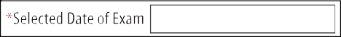
 | International English Olympiad |  | National Science Olympiad |  |  |  | National Mathematics Olympiad |  |  |  | National Commerce Olympiad
 | Date  of Exam |  | Date  of Exam |  |  |  | Date  of Exam |  |  |  | Date  of Exam
11
12
 | 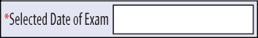 |  |  |  |  |  |  |  |  |  | 

SIGNATURE OLYMPIAD FOUNDATION,
Salem, Tamilnadu.

dbcbank.com

- Registration fee : School in the India, Bangladesh, Bhutan & Nepal Pay to Signature a Registration fee of `250* (including GST) per s t u d e n t / O l y m p i a d t o w a r d s c o s t o f e x a m i n a t i o n . School may charge an additional `25** per student towards honorarium Incharge, remuneration to teachers to teach and guide, and for other expenses. No fee is payable for students suffering from any major physical disability, or an Indian student whose parent was martyred during Defence operations.
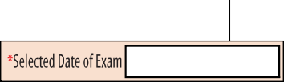
*US$18 for other countries **US$ 2 for other countries

Principal’s signature date and school stamp
* Please select date for conducting the SIGNATURE OLYMPIAD in your school. Change of date will not be permitted. There are separate question papers for different dates.
This form may be sent to
Ramalakshman Towers, Sriram Nagar, Behind RBS Bank, Alagapuram
Periyaputhur, Salem, Tamilnadu - 636 016, India.
by 30 days before date of exam. | PLEASE DO NOT PAY CASH.


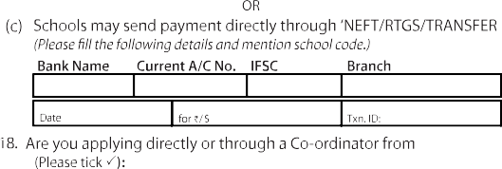

DBS 0695360000001576 DBSS0IN0695 Suramangalam,Salem

Signature Olympiad?

